DOF Cancel UC3 Flow Document
In Dap UI order in Activating state
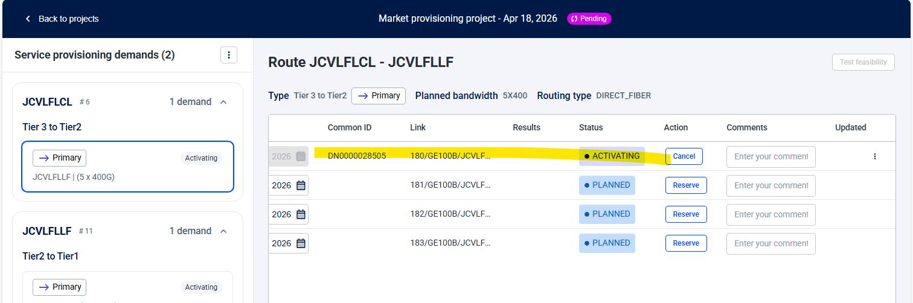

Strand status_code are IN-USE for clfi
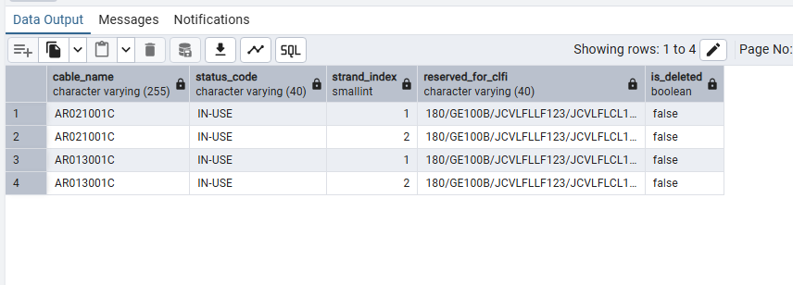

In Mowfm order is in pending edge completion
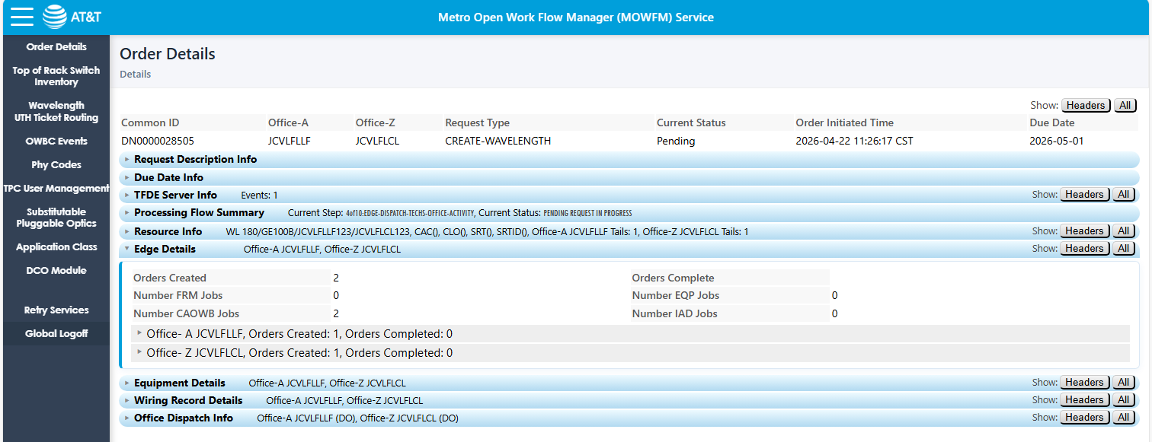
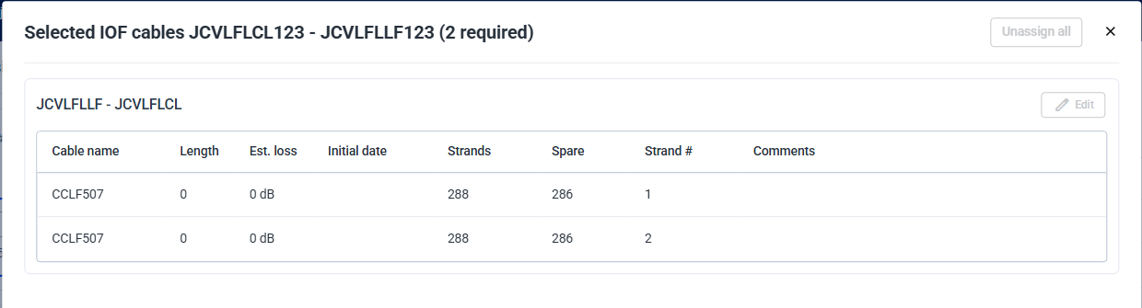

Click on Cancel button and click on stop process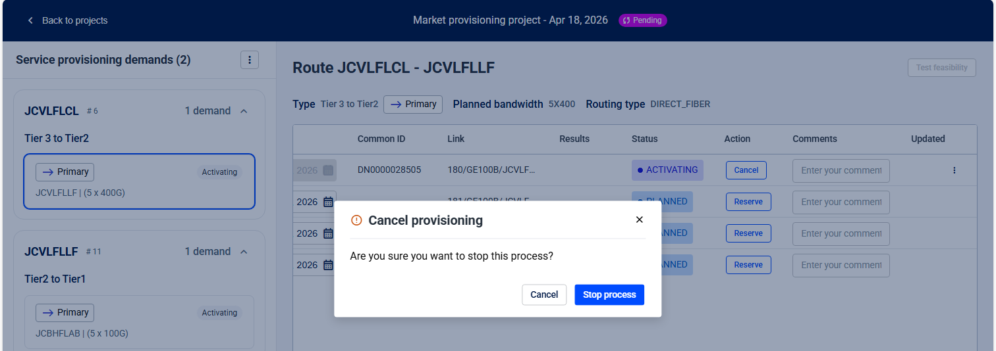

These workflow got triggered in DAP UI
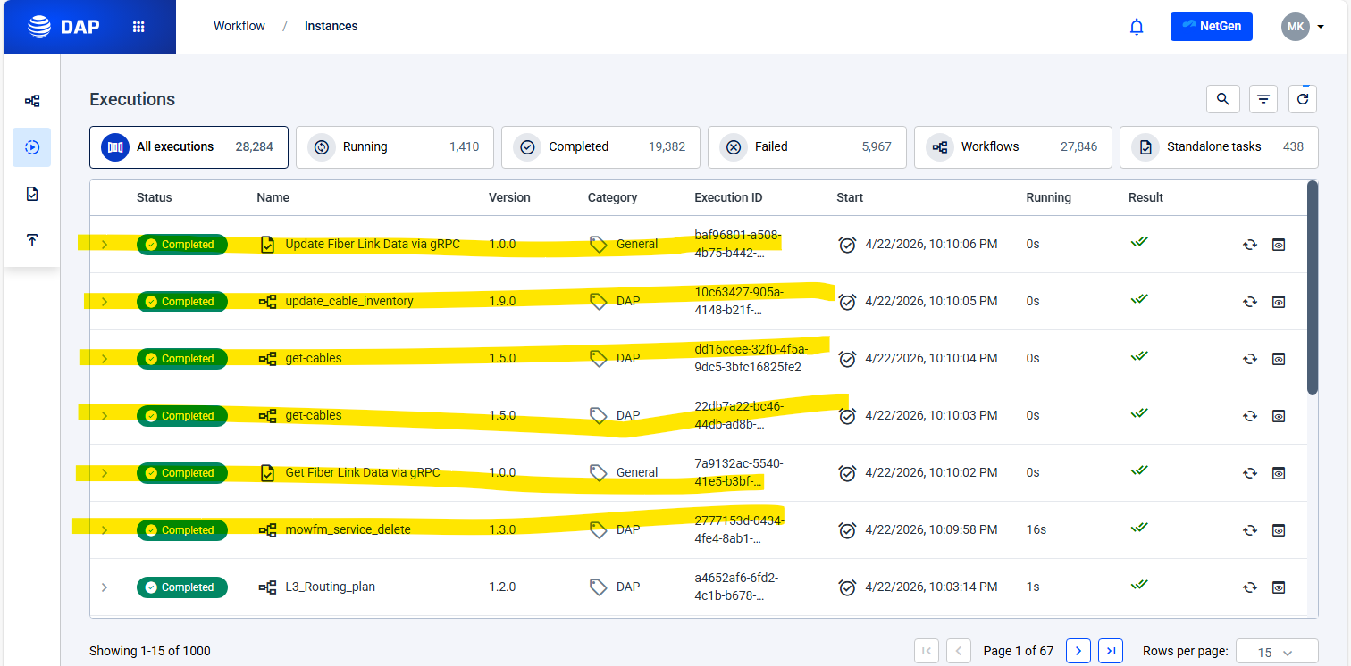

MowfmServiceDelete
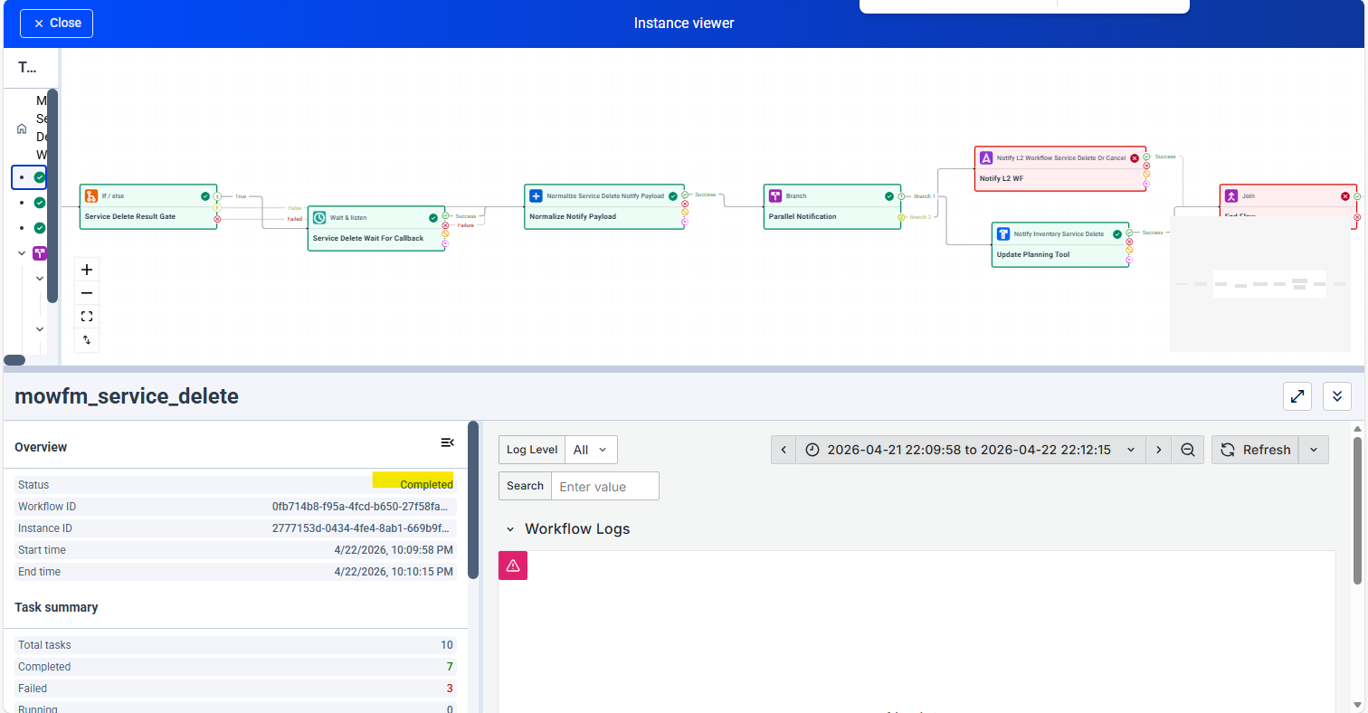
Request:
{
"common_id": "DN0000028505C",
"dapRequestHeader": {
"wavelengthRequestType": "Direct-Fiber",
"rpcAction": "service-delete"
},
"sdncRequestHeader": {
"rpcAction": "service-delete"
},
"serviceDeleteReqInfo": {
"tailRetention": "no",
"serviceName": "180/GE100B/JCVLFLLF123/JCVLFLCL123",
"dueDate": "2026-05-01T20:37:38.000Z"
},
"outbound_call_details": {
"auth": {
"type": "basic",
"password": "hashicorpkv:secrets/kv/dap/azure/workflow-engine-worker/MOWFM_PASSWORD",
"username": "hashicorpkv:secrets/kv/dap/azure/workflow-engine-worker/MOWFM_USERNAME"
},
"path": "/mowfm_api/MOWFMService/dap/service-delete/WAVELENGTH/v2",
"proxy": "http://proxy.conexus.svc.local:3128",
"method": "POST",
"timeout": 60,
"trust_env": false,
"verify_ssl": false,
"retry_count": 2,
"retry_delay": 20
},
"notification_url_prefix": "/api/wait-and-listen/listener/mowfm-service-delete-2777153d-0434-4fe4-8ab1-669b9f1de5f3"
}
Response:
{
"data": {
"common-id": "DN0000028505C",
"is-ack": true,
"request-action": "service-delete",
"response-info": {
"result": "SUCCESS"
},
"response-code": 200,
"sync_result": "SUCCESS"
},
"metadata": {
"activity_name": "service_delete"
}
}

Get Fiber Link Data via gRPC
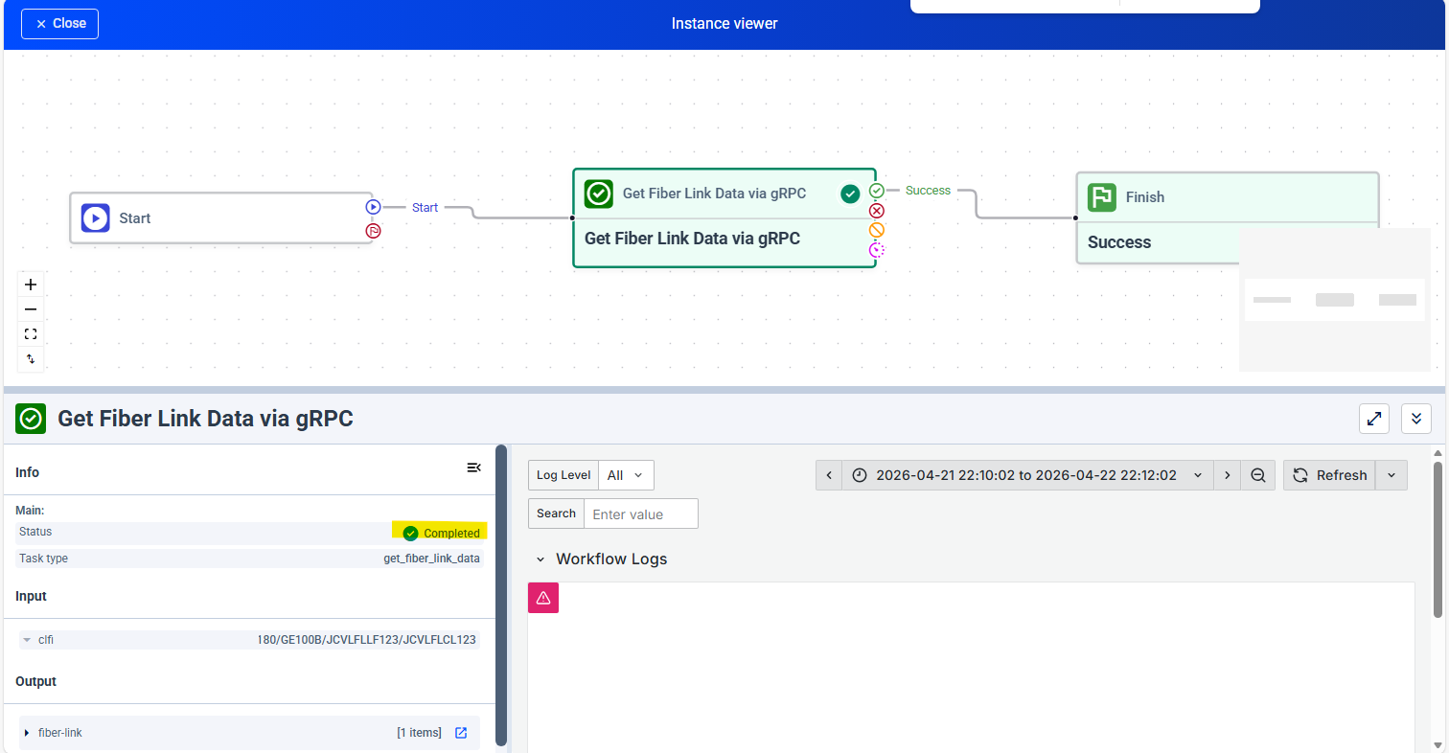
Request:
{
"task_name": "Get Fiber Link Data via gRPC",
"task_id": "87337e13-257a-4b48-9e56-c63922ed61bf",
"task_version": "1.0.0",
"task_version_id": "8ee428f5-524c-4d2a-b396-f89e959761cb",
"task_type": "PREDEFINED",
"temporal_activity_name": "get_fiber_link_data",
"arguments": {
"clfi": "180/GE100B/JCVLFLLF123/JCVLFLCL123"
},
"timeout_seconds": null
}
Response:
{
"success": true,
"result": {
"data": {
"fiber-link": [
{
"clfi": "180/GE100B/JCVLFLLF123/JCVLFLCL123",
"action": "Update",
"info": {
"a-clli": "JCVLFLLF",
"z-clli": "JCVLFLCL",
"lifecycle-state": "activating",
"common-id": "",
"due-date": "2026-05-01T20:37:38.000Z"
},
"circuit-details": {
"cac": "",
"clo": "",
"a-to-z-circuit": {
"circuit-connector": [
{
"sequence-number": 1,
"type": "router-port",
"device-name": "JCVLFLLF123",
"rack": "010130.01",
"shelf": "04",
"port": "ge100-0/0/0",
"clli": "JCVLFLLF",
"tail-clfi": "",
"source": null,
"destination": null,
"tail-topology": null,
"estimated-tail-span-loss": 0,
"cable": "",
"facility-detail": "",
"sub-path": "",
"distance": 0,
"distance-unit": "",
"span-loss": 0,
"cable-strand-number": 0
},
{
"sequence-number": 2,
"type": "fiber-tail",
"device-name": "",
"rack": "",
"shelf": "",
"port": "",
"clli": "",
"tail-clfi": "28505t/GE400N/JCVLFLLF/JCVLFLLF",
"source": {
"clli": "JCVLFLLF",
"shelf": "04",
"rack": "010130.01",
"port": "ge100-0/0/0"
},
"destination": {
"clli": "JCVLFLLF",
"shelf": "01",
"rack": "010124.17",
"port": "1"
},
"tail-topology": {
"record-entry": [
{
"sequence-number": 1,
"resource": {
"type": "jumper",
"cable-name": "",
"strand-identifier": 0,
"source": {
"clli": "",
"shelf": "04",
"rack": "010130.01",
"port": "ge100-0/0/0"
},
"destination": {
"clli": "",
"shelf": "0C",
"rack": "010130.01",
"port": "1"
}
}
},
{
"sequence-number": 2,
"resource": {
"type": "fiber-cable-strand",
"cable-name": "AR013001C",
"strand-identifier": 1,
"source": {
"clli": "",
"shelf": "0C",
"rack": "010130.01",
"port": "1"
},
"destination": {
"clli": "",
"shelf": "08",
"rack": "010124.18",
"port": "1"
}
}
},
{
"sequence-number": 3,
"resource": {
"type": "jumper",
"cable-name": "",
"strand-identifier": 0,
"source": {
"clli": "",
"shelf": "08",
"rack": "010124.18",
"port": "1"
},
"destination": {
"clli": "",
"shelf": "01",
"rack": "010124.17",
"port": "1"
}
}
}
]
},
"estimated-tail-span-loss": 4,
"cable": "",
"facility-detail": "",
"sub-path": "",
"distance": 0,
"distance-unit": "",
"span-loss": 0,
"cable-strand-number": 0
},
{
"sequence-number": 3,
"type": "iof-cable-strand",
"device-name": "",
"rack": "",
"shelf": "",
"port": "",
"clli": "",
"tail-clfi": "",
"source": {
"clli": "JCVLFLLF",
"shelf": "01",
"rack": "010124.17",
"port": "1"
},
"destination": {
"clli": "JCVLFLCL",
"shelf": "05",
"rack": "020209.13",
"port": "1"
},
"tail-topology": null,
"estimated-tail-span-loss": 0,
"cable": "00003b0a-11cb-4e37-87c3-5383852d048e",
"facility-detail": "",
"sub-path": "",
"distance": 0,
"distance-unit": "",
"span-loss": 0.5,
"cable-strand-number": 1
},
{
"sequence-number": 4,
"type": "fiber-tail",
"device-name": "",
"rack": "",
"shelf": "",
"port": "",
"clli": "",
"tail-clfi": "28505t/GE400N/JCVLFLCL/JCVLFLCL",
"source": {
"clli": "JCVLFLCL",
"shelf": "05",
"rack": "020209.13",
"port": "1"
},
"destination": {
"clli": "JCVLFLCL",
"shelf": "04",
"rack": "020210.01",
"port": "ge10-0/0/0"
},
"tail-topology": {
"record-entry": [
{
"sequence-number": 1,
"resource": {
"type": "jumper",
"cable-name": "",
"strand-identifier": 0,
"source": {
"clli": "",
"shelf": "05",
"rack": "020209.13",
"port": "1"
},
"destination": {
"clli": "",
"shelf": "05",
"rack": "020209.14",
"port": "2"
}
}
},
{
"sequence-number": 2,
"resource": {
"type": "fiber-cable-strand",
"cable-name": "AR021001C",
"strand-identifier": 2,
"source": {
"clli": "",
"shelf": "05",
"rack": "020209.14",
"port": "2"
},
"destination": {
"clli": "",
"shelf": "0C",
"rack": "020210.01",
"port": "2"
}
}
},
{
"sequence-number": 3,
"resource": {
"type": "jumper",
"cable-name": "",
"strand-identifier": 0,
"source": {
"clli": "",
"shelf": "0C",
"rack": "020210.01",
"port": "2"
},
"destination": {
"clli": "",
"shelf": "04",
"rack": "020210.01",
"port": "ge10-0/0/0"
}
}
}
]
},
"estimated-tail-span-loss": 4,
"cable": "",
"facility-detail": "",
"sub-path": "",
"distance": 0,
"distance-unit": "",
"span-loss": 0,
"cable-strand-number": 0
},
{
"sequence-number": 5,
"type": "router-port",
"device-name": "JCVLFLCL123",
"rack": "020210.01",
"shelf": "04",
"port": "ge10-0/0/0",
"clli": "JCVLFLCL",
"tail-clfi": "",
"source": null,
"destination": null,
"tail-topology": null,
"estimated-tail-span-loss": 0,
"cable": "",
"facility-detail": "",
"sub-path": "",
"distance": 0,
"distance-unit": "",
"span-loss": 0,
"cable-strand-number": 0
}
],
"total-estimated-loss": "8.5"
},
"z-to-a-circuit": {
"circuit-connector": [
{
"sequence-number": 1,
"type": "router-port",
"device-name": "JCVLFLCL123",
"rack": "020210.01",
"shelf": "04",
"port": "ge10-0/0/0",
"clli": "JCVLFLCL",
"tail-clfi": "",
"source": null,
"destination": null,
"tail-topology": null,
"estimated-tail-span-loss": 0,
"cable": "",
"facility-detail": "",
"sub-path": "",
"distance": 0,
"distance-unit": "",
"span-loss": 0,
"cable-strand-number": 0
},
{
"sequence-number": 2,
"type": "fiber-tail",
"device-name": "",
"rack": "",
"shelf": "",
"port": "",
"clli": "",
"tail-clfi": "28505t/GE400N/JCVLFLCL/JCVLFLCL",
"source": {
"clli": "JCVLFLCL",
"shelf": "04",
"rack": "020210.01",
"port": "ge10-0/0/0"
},
"destination": {
"clli": "JCVLFLCL",
"shelf": "05",
"rack": "020209.13",
"port": "2"
},
"tail-topology": {
"record-entry": [
{
"sequence-number": 3,
"resource": {
"type": "jumper",
"cable-name": "",
"strand-identifier": 0,
"source": {
"clli": "",
"shelf": "05",
"rack": "020209.14",
"port": "1"
},
"destination": {
"clli": "",
"shelf": "05",
"rack": "020209.13",
"port": "2"
}
}
},
{
"sequence-number": 2,
"resource": {
"type": "fiber-cable-strand",
"cable-name": "AR021001C",
"strand-identifier": 1,
"source": {
"clli": "",
"shelf": "0C",
"rack": "020210.01",
"port": "1"
},
"destination": {
"clli": "",
"shelf": "05",
"rack": "020209.14",
"port": "1"
}
}
},
{
"sequence-number": 1,
"resource": {
"type": "jumper",
"cable-name": "",
"strand-identifier": 0,
"source": {
"clli": "",
"shelf": "04",
"rack": "020210.01",
"port": "ge10-0/0/0"
},
"destination": {
"clli": "",
"shelf": "0C",
"rack": "020210.01",
"port": "1"
}
}
}
]
},
"estimated-tail-span-loss": 4,
"cable": "",
"facility-detail": "",
"sub-path": "",
"distance": 0,
"distance-unit": "",
"span-loss": 0,
"cable-strand-number": 0
},
{
"sequence-number": 3,
"type": "iof-cable-strand",
"device-name": "",
"rack": "",
"shelf": "",
"port": "",
"clli": "",
"tail-clfi": "",
"source": {
"clli": "JCVLFLCL",
"shelf": "05",
"rack": "020209.13",
"port": "2"
},
"destination": {
"clli": "JCVLFLLF",
"shelf": "01",
"rack": "010124.17",
"port": "2"
},
"tail-topology": null,
"estimated-tail-span-loss": 0,
"cable": "00003b0a-11cb-4e37-87c3-5383852d048e",
"facility-detail": "",
"sub-path": "",
"distance": 0,
"distance-unit": "",
"span-loss": 0.5,
"cable-strand-number": 2
},
{
"sequence-number": 4,
"type": "fiber-tail",
"device-name": "",
"rack": "",
"shelf": "",
"port": "",
"clli": "",
"tail-clfi": "28505t/GE400N/JCVLFLLF/JCVLFLLF",
"source": {
"clli": "JCVLFLLF",
"shelf": "01",
"rack": "010124.17",
"port": "2"
},
"destination": {
"clli": "JCVLFLLF",
"shelf": "04",
"rack": "010130.01",
"port": "ge100-0/0/0"
},
"tail-topology": {
"record-entry": [
{
"sequence-number": 3,
"resource": {
"type": "jumper",
"cable-name": "",
"strand-identifier": 0,
"source": {
"clli": "",
"shelf": "0C",
"rack": "010130.01",
"port": "2"
},
"destination": {
"clli": "",
"shelf": "04",
"rack": "010130.01",
"port": "ge100-0/0/0"
}
}
},
{
"sequence-number": 2,
"resource": {
"type": "fiber-cable-strand",
"cable-name": "AR013001C",
"strand-identifier": 2,
"source": {
"clli": "",
"shelf": "08",
"rack": "010124.18",
"port": "2"
},
"destination": {
"clli": "",
"shelf": "0C",
"rack": "010130.01",
"port": "2"
}
}
},
{
"sequence-number": 1,
"resource": {
"type": "jumper",
"cable-name": "",
"strand-identifier": 0,
"source": {
"clli": "",
"shelf": "01",
"rack": "010124.17",
"port": "2"
},
"destination": {
"clli": "",
"shelf": "08",
"rack": "010124.18",
"port": "2"
}
}
}
]
},
"estimated-tail-span-loss": 4,
"cable": "",
"facility-detail": "",
"sub-path": "",
"distance": 0,
"distance-unit": "",
"span-loss": 0,
"cable-strand-number": 0
},
{
"sequence-number": 5,
"type": "router-port",
"device-name": "JCVLFLLF123",
"rack": "010130.01",
"shelf": "04",
"port": "ge100-0/0/0",
"clli": "JCVLFLLF",
"tail-clfi": "",
"source": null,
"destination": null,
"tail-topology": null,
"estimated-tail-span-loss": 0,
"cable": "",
"facility-detail": "",
"sub-path": "",
"distance": 0,
"distance-unit": "",
"span-loss": 0,
"cable-strand-number": 0
}
],
"total-estimated-loss": "8.5"
}
}
}
]
},
"metadata": {
"activity_name": "get_fiber_link_data"
}
},
"error": null
}

Get-cables
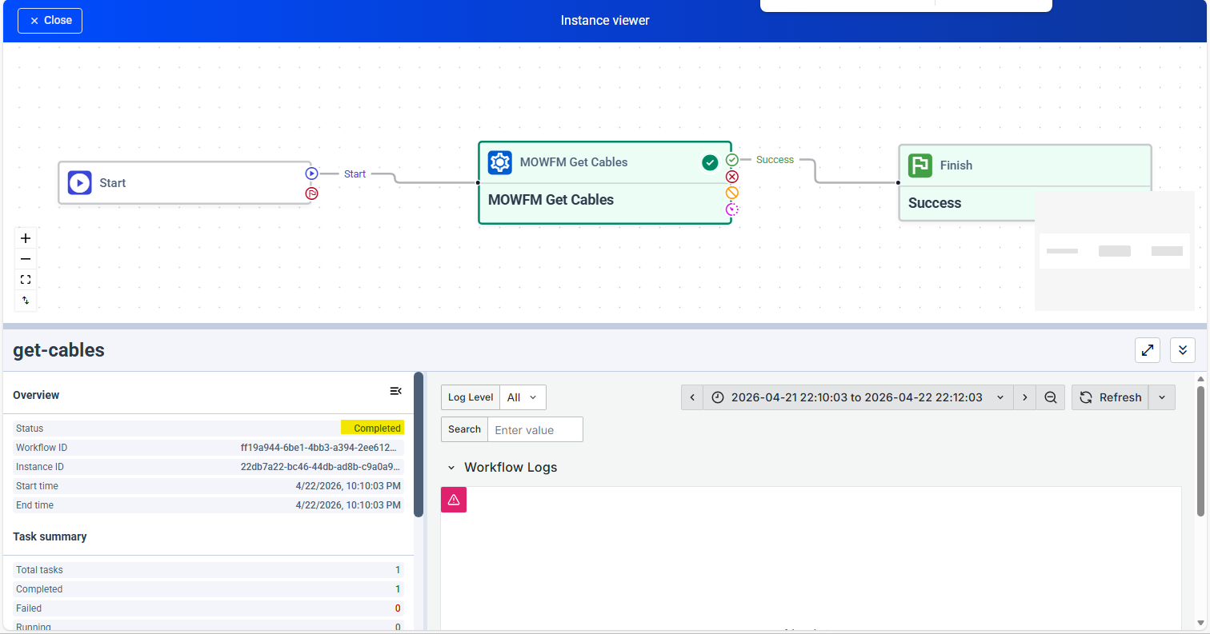
Request :
{
"cable_names": [
"AR013001C"
],
"inventory_url": "inventory-resources:5000",
"a_location_clli": "JCVLFLLF",
"z_location_clli": "{{z_location_clli}}"
}
Response:
{
"data": {
"response-info": {
"result": "SUCCESS",
"error-type": "",
"error-code": [],
"error-description": ""
},
"fiber-cable": [
{
"name": "AR013001C",
"length": 100,
"number-of-strands": 144,
"type": "FT",
"lifecycle-state": "deployed",
"direction": "east",
"source": {
"clli": "JCVLFLLF",
"rack": "010130.01",
"termination-type": "LGX"
},
"destination": {
"clli": "JCVLFLLF",
"rack": "010124.18",
"termination-type": "LGX"
},
"fiber-cable-strand": [
{
"strand-number": 1,
"allocation": "assigned",
"assignment": "180/GE100B/JCVLFLLF123/JCVLFLCL123",
"source": {
"shelf": "0C",
"port": 1
},
"destination": {
"shelf": "08",
"port": 1
}
},
{
"strand-number": 2,
"allocation": "assigned",
"assignment": "180/GE100B/JCVLFLLF123/JCVLFLCL123",
"source": {
"shelf": "0C",
"port": 2
},
"destination": {
"shelf": "08",
"port": 2
}
}
]
}
]
},
"metadata": {
"activity_name": "mowfm_get_cables"
}
}

Get-cables
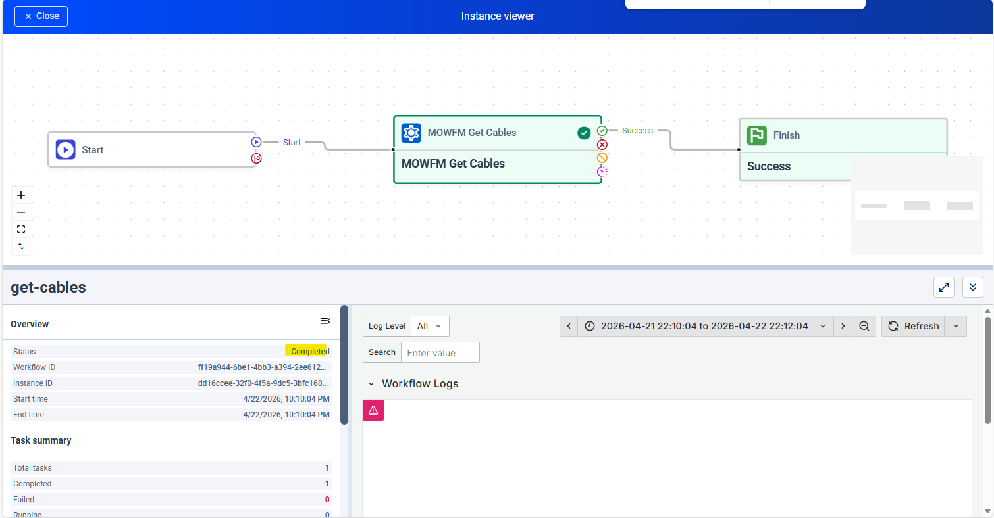
Request :
{
"cable_names": [
"AR021001C"
],
"inventory_url": "inventory-resources:5000",
"a_location_clli": "JCVLFLCL",
"z_location_clli": "{{z_location_clli}}"
}
Response:
{
"data": {
"response-info": {
"result": "SUCCESS",
"error-type": "",
"error-code": [],
"error-description": ""
},
"fiber-cable": [
{
"name": "AR021001C",
"length": 100,
"number-of-strands": 144,
"type": "FT",
"lifecycle-state": "deployed",
"direction": "east",
"source": {
"clli": "JCVLFLCL",
"rack": "020210.01",
"termination-type": "LGX"
},
"destination": {
"clli": "JCVLFLCL",
"rack": "020209.14",
"termination-type": "LGX"
},
"fiber-cable-strand": [
{
"strand-number": 1,
"allocation": "assigned",
"assignment": "180/GE100B/JCVLFLLF123/JCVLFLCL123",
"source": {
"shelf": "0C",
"port": 1
},
"destination": {
"shelf": "05",
"port": 1
}
},
{
"strand-number": 2,
"allocation": "assigned",
"assignment": "180/GE100B/JCVLFLLF123/JCVLFLCL123",
"source": {
"shelf": "0C",
"port": 2
},
"destination": {
"shelf": "05",
"port": 2
}
}
]
}
]
},
"metadata": {
"activity_name": "mowfm_get_cables"
}
}

Update_cable_inventory
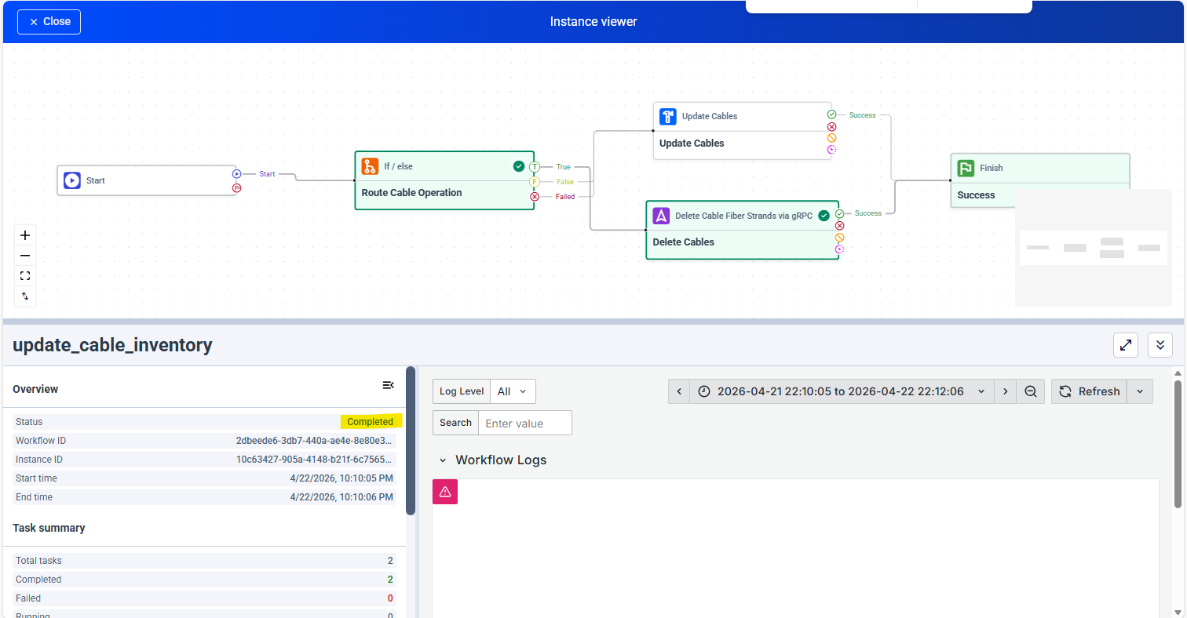
Request:
{
"fiber-cable": [
{
"fiber-cable-strand": [
{
"allocation": "spare",
"assignment": "180/GE100B/JCVLFLLF123/JCVLFLCL123",
"strand-number": 1
},
{
"allocation": "spare",
"assignment": "180/GE100B/JCVLFLLF123/JCVLFLCL123",
"strand-number": 2
}
],
"lifecycle-state": "deployed",
"name": "AR013001C",
"direction": "east",
"number-of-strands": 144
},
{
"fiber-cable-strand": [
{
"allocation": "spare",
"assignment": "180/GE100B/JCVLFLLF123/JCVLFLCL123",
"strand-number": 1
},
{
"allocation": "spare",
"assignment": "180/GE100B/JCVLFLLF123/JCVLFLCL123",
"strand-number": 2
}
],
"lifecycle-state": "deployed",
"name": "AR021001C",
"direction": "east",
"number-of-strands": 144
}
],
"inventory_url": "inventory-resources:5000"
}
Response:
{
"data": {
"response-info": {
"result": "SUCCESS",
"error-type": "",
"error-code": [],
"error-description": ""
},
"fiber-cable": [
{
"direction": "east",
"lifecycle-state": "deployed",
"name": "AR013001C",
"number-of-strands": 144,
"fiber-cable-strand": [
{
"allocation": "SPARE",
"source": {
"port": "1"
},
"destination": {
"port": "1"
}
},
{
"allocation": "SPARE",
"source": {
"port": "2"
},
"destination": {
"port": "2"
}
},
{
"allocation": "SPARE",
"source": {
"port": "1"
},
"destination": {
"port": "1"
}
},
{
"allocation": "SPARE",
"source": {
"port": "2"
},
"destination": {
"port": "2"
}
}
]
},
{
"direction": "east",
"lifecycle-state": "deployed",
"name": "AR021001C",
"number-of-strands": 144,
"fiber-cable-strand": []
}
]
},
"metadata": {
"activity_name": "delete_cable_fiber_strands"
}
}

Update Fiber Link Data via gRPC
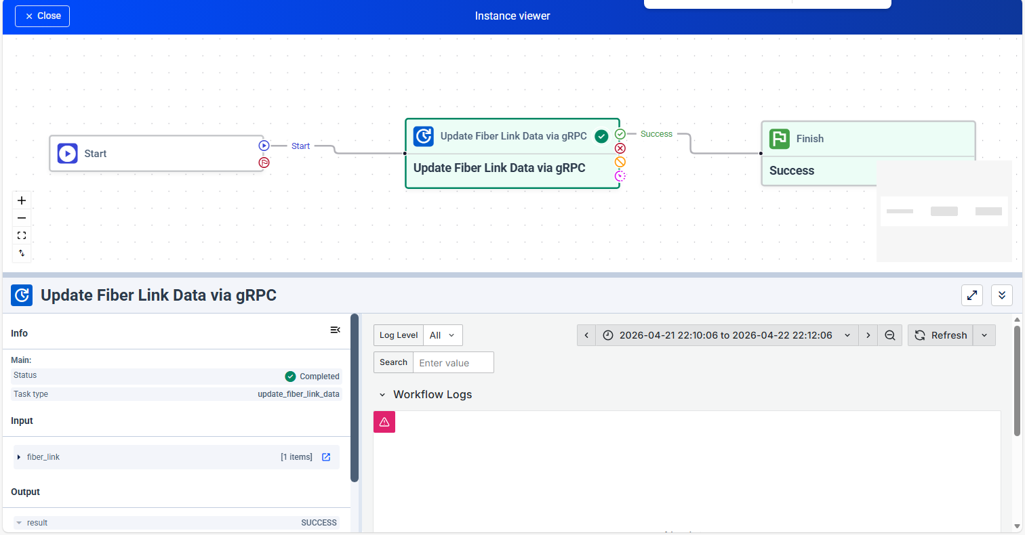
Request:
{
"task_name": "Update Fiber Link Data via gRPC",
"task_id": "45a5e7d8-cadd-40e8-adc9-613a9c24aeae",
"task_version": "1.0.0",
"task_version_id": "9cf33e3f-8cdb-4beb-bb65-2c16151f0055",
"task_type": "PREDEFINED",
"temporal_activity_name": "update_fiber_link_data",
"arguments": {
"fiber-link": [
{
"clfi": "180/GE100B/JCVLFLLF123/JCVLFLCL123",
"action": "Delete",
"info": {
"a-clli": "JCVLFLLF",
"z-clli": "JCVLFLCL",
"common-id": "",
"lifecycle-state": "activating",
"due-date": "2026-05-01T20:37:38.000Z"
},
"circuit-details": {
"cac": "",
"clo": "",
"a-to-z-circuit": {
"circuit-connector": [
{
"sequence-number": 1,
"type": "router-port",
"device-name": "JCVLFLLF123",
"rack": "010130.01",
"shelf": "04",
"port": "ge100-0/0/0",
"clli": "JCVLFLLF",
"cable": "",
"facility-detail": "",
"sub-path": "",
"distance": 0,
"distance-unit": "",
"span-loss": 0,
"cable-strand-number": 0,
"tail-clfi": "",
"estimated-tail-span-loss": 0
},
{
"sequence-number": 2,
"type": "fiber-tail",
"device-name": "",
"rack": "",
"shelf": "",
"port": "",
"clli": "",
"cable": "",
"facility-detail": "",
"sub-path": "",
"distance": 0,
"distance-unit": "",
"span-loss": 0,
"cable-strand-number": 0,
"source": {
"clli": "JCVLFLLF",
"shelf": "04",
"rack": "010130.01",
"port": "ge100-0/0/0"
},
"destination": {
"clli": "JCVLFLLF",
"shelf": "01",
"rack": "010124.17",
"port": "1"
},
"tail-clfi": "28505t/GE400N/JCVLFLLF/JCVLFLLF",
"tail-topology": {
"record-entry": [
{
"sequence-number": 1,
"resource": {
"type": "jumper",
"source": {
"clli": "",
"shelf": "04",
"rack": "010130.01",
"port": "ge100-0/0/0"
},
"destination": {
"clli": "",
"shelf": "0C",
"rack": "010130.01",
"port": "1"
},
"cable-name": "",
"strand-identifier": 0
}
},
{
"sequence-number": 2,
"resource": {
"type": "fiber-cable-strand",
"source": {
"clli": "",
"shelf": "0C",
"rack": "010130.01",
"port": "1"
},
"destination": {
"clli": "",
"shelf": "08",
"rack": "010124.18",
"port": "1"
},
"cable-name": "AR013001C",
"strand-identifier": 1
}
},
{
"sequence-number": 3,
"resource": {
"type": "jumper",
"source": {
"clli": "",
"shelf": "08",
"rack": "010124.18",
"port": "1"
},
"destination": {
"clli": "",
"shelf": "01",
"rack": "010124.17",
"port": "1"
},
"cable-name": "",
"strand-identifier": 0
}
}
]
},
"estimated-tail-span-loss": 4
},
{
"sequence-number": 3,
"type": "iof-cable-strand",
"device-name": "",
"rack": "",
"shelf": "",
"port": "",
"clli": "",
"cable": "00003b0a-11cb-4e37-87c3-5383852d048e",
"facility-detail": "",
"sub-path": "",
"distance": 0,
"distance-unit": "",
"span-loss": 0.5,
"cable-strand-number": 1,
"source": {
"clli": "JCVLFLLF",
"shelf": "01",
"rack": "010124.17",
"port": "1"
},
"destination": {
"clli": "JCVLFLCL",
"shelf": "05",
"rack": "020209.13",
"port": "1"
},
"tail-clfi": "",
"estimated-tail-span-loss": 0
},
{
"sequence-number": 4,
"type": "fiber-tail",
"device-name": "",
"rack": "",
"shelf": "",
"port": "",
"clli": "",
"cable": "",
"facility-detail": "",
"sub-path": "",
"distance": 0,
"distance-unit": "",
"span-loss": 0,
"cable-strand-number": 0,
"source": {
"clli": "JCVLFLCL",
"shelf": "05",
"rack": "020209.13",
"port": "1"
},
"destination": {
"clli": "JCVLFLCL",
"shelf": "04",
"rack": "020210.01",
"port": "ge10-0/0/0"
},
"tail-clfi": "28505t/GE400N/JCVLFLCL/JCVLFLCL",
"tail-topology": {
"record-entry": [
{
"sequence-number": 1,
"resource": {
"type": "jumper",
"source": {
"clli": "",
"shelf": "05",
"rack": "020209.13",
"port": "1"
},
"destination": {
"clli": "",
"shelf": "05",
"rack": "020209.14",
"port": "2"
},
"cable-name": "",
"strand-identifier": 0
}
},
{
"sequence-number": 2,
"resource": {
"type": "fiber-cable-strand",
"source": {
"clli": "",
"shelf": "05",
"rack": "020209.14",
"port": "2"
},
"destination": {
"clli": "",
"shelf": "0C",
"rack": "020210.01",
"port": "2"
},
"cable-name": "AR021001C",
"strand-identifier": 2
}
},
{
"sequence-number": 3,
"resource": {
"type": "jumper",
"source": {
"clli": "",
"shelf": "0C",
"rack": "020210.01",
"port": "2"
},
"destination": {
"clli": "",
"shelf": "04",
"rack": "020210.01",
"port": "ge10-0/0/0"
},
"cable-name": "",
"strand-identifier": 0
}
}
]
},
"estimated-tail-span-loss": 4
},
{
"sequence-number": 5,
"type": "router-port",
"device-name": "JCVLFLCL123",
"rack": "020210.01",
"shelf": "04",
"port": "ge10-0/0/0",
"clli": "JCVLFLCL",
"cable": "",
"facility-detail": "",
"sub-path": "",
"distance": 0,
"distance-unit": "",
"span-loss": 0,
"cable-strand-number": 0,
"tail-clfi": "",
"estimated-tail-span-loss": 0
}
],
"total-estimated-loss": "8.5"
},
"z-to-a-circuit": {
"circuit-connector": [
{
"sequence-number": 1,
"type": "router-port",
"device-name": "JCVLFLCL123",
"rack": "020210.01",
"shelf": "04",
"port": "ge10-0/0/0",
"clli": "JCVLFLCL",
"cable": "",
"facility-detail": "",
"sub-path": "",
"distance": 0,
"distance-unit": "",
"span-loss": 0,
"cable-strand-number": 0,
"tail-clfi": "",
"estimated-tail-span-loss": 0
},
{
"sequence-number": 2,
"type": "fiber-tail",
"device-name": "",
"rack": "",
"shelf": "",
"port": "",
"clli": "",
"cable": "",
"facility-detail": "",
"sub-path": "",
"distance": 0,
"distance-unit": "",
"span-loss": 0,
"cable-strand-number": 0,
"source": {
"clli": "JCVLFLCL",
"shelf": "04",
"rack": "020210.01",
"port": "ge10-0/0/0"
},
"destination": {
"clli": "JCVLFLCL",
"shelf": "05",
"rack": "020209.13",
"port": "2"
},
"tail-clfi": "28505t/GE400N/JCVLFLCL/JCVLFLCL",
"tail-topology": {
"record-entry": [
{
"sequence-number": 3,
"resource": {
"type": "jumper",
"source": {
"clli": "",
"shelf": "05",
"rack": "020209.14",
"port": "1"
},
"destination": {
"clli": "",
"shelf": "05",
"rack": "020209.13",
"port": "2"
},
"cable-name": "",
"strand-identifier": 0
}
},
{
"sequence-number": 2,
"resource": {
"type": "fiber-cable-strand",
"source": {
"clli": "",
"shelf": "0C",
"rack": "020210.01",
"port": "1"
},
"destination": {
"clli": "",
"shelf": "05",
"rack": "020209.14",
"port": "1"
},
"cable-name": "AR021001C",
"strand-identifier": 1
}
},
{
"sequence-number": 1,
"resource": {
"type": "jumper",
"source": {
"clli": "",
"shelf": "04",
"rack": "020210.01",
"port": "ge10-0/0/0"
},
"destination": {
"clli": "",
"shelf": "0C",
"rack": "020210.01",
"port": "1"
},
"cable-name": "",
"strand-identifier": 0
}
}
]
},
"estimated-tail-span-loss": 4
},
{
"sequence-number": 3,
"type": "iof-cable-strand",
"device-name": "",
"rack": "",
"shelf": "",
"port": "",
"clli": "",
"cable": "00003b0a-11cb-4e37-87c3-5383852d048e",
"facility-detail": "",
"sub-path": "",
"distance": 0,
"distance-unit": "",
"span-loss": 0.5,
"cable-strand-number": 2,
"source": {
"clli": "JCVLFLCL",
"shelf": "05",
"rack": "020209.13",
"port": "2"
},
"destination": {
"clli": "JCVLFLLF",
"shelf": "01",
"rack": "010124.17",
"port": "2"
},
"tail-clfi": "",
"estimated-tail-span-loss": 0
},
{
"sequence-number": 4,
"type": "fiber-tail",
"device-name": "",
"rack": "",
"shelf": "",
"port": "",
"clli": "",
"cable": "",
"facility-detail": "",
"sub-path": "",
"distance": 0,
"distance-unit": "",
"span-loss": 0,
"cable-strand-number": 0,
"source": {
"clli": "JCVLFLLF",
"shelf": "01",
"rack": "010124.17",
"port": "2"
},
"destination": {
"clli": "JCVLFLLF",
"shelf": "04",
"rack": "010130.01",
"port": "ge100-0/0/0"
},
"tail-clfi": "28505t/GE400N/JCVLFLLF/JCVLFLLF",
"tail-topology": {
"record-entry": [
{
"sequence-number": 3,
"resource": {
"type": "jumper",
"source": {
"clli": "",
"shelf": "0C",
"rack": "010130.01",
"port": "2"
},
"destination": {
"clli": "",
"shelf": "04",
"rack": "010130.01",
"port": "ge100-0/0/0"
},
"cable-name": "",
"strand-identifier": 0
}
},
{
"sequence-number": 2,
"resource": {
"type": "fiber-cable-strand",
"source": {
"clli": "",
"shelf": "08",
"rack": "010124.18",
"port": "2"
},
"destination": {
"clli": "",
"shelf": "0C",
"rack": "010130.01",
"port": "2"
},
"cable-name": "AR013001C",
"strand-identifier": 2
}
},
{
"sequence-number": 1,
"resource": {
"type": "jumper",
"source": {
"clli": "",
"shelf": "01",
"rack": "010124.17",
"port": "2"
},
"destination": {
"clli": "",
"shelf": "08",
"rack": "010124.18",
"port": "2"
},
"cable-name": "",
"strand-identifier": 0
}
}
]
},
"estimated-tail-span-loss": 4
},
{
"sequence-number": 5,
"type": "router-port",
"device-name": "JCVLFLLF123",
"rack": "010130.01",
"shelf": "04",
"port": "ge100-0/0/0",
"clli": "JCVLFLLF",
"cable": "",
"facility-detail": "",
"sub-path": "",
"distance": 0,
"distance-unit": "",
"span-loss": 0,
"cable-strand-number": 0,
"tail-clfi": "",
"estimated-tail-span-loss": 0
}
],
"total-estimated-loss": "8.5"
}
}
}
]
},
"timeout_seconds": null
}
Response:
{
"success": true,
"result": {
"data": {
"result": "SUCCESS",
"error-type": null,
"error-code": [],
"error-description": null
},
"metadata": {
"activity_name": "update_fiber_link_data"
}
},
"error": null
}

After all workflow got completed. In Mowfm status showing as Completed
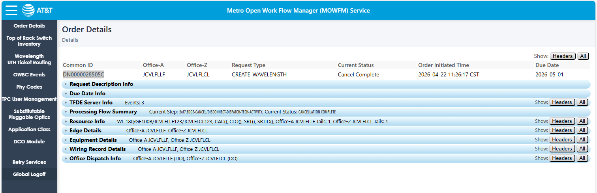

Dap status changed from cancelling to Reserved
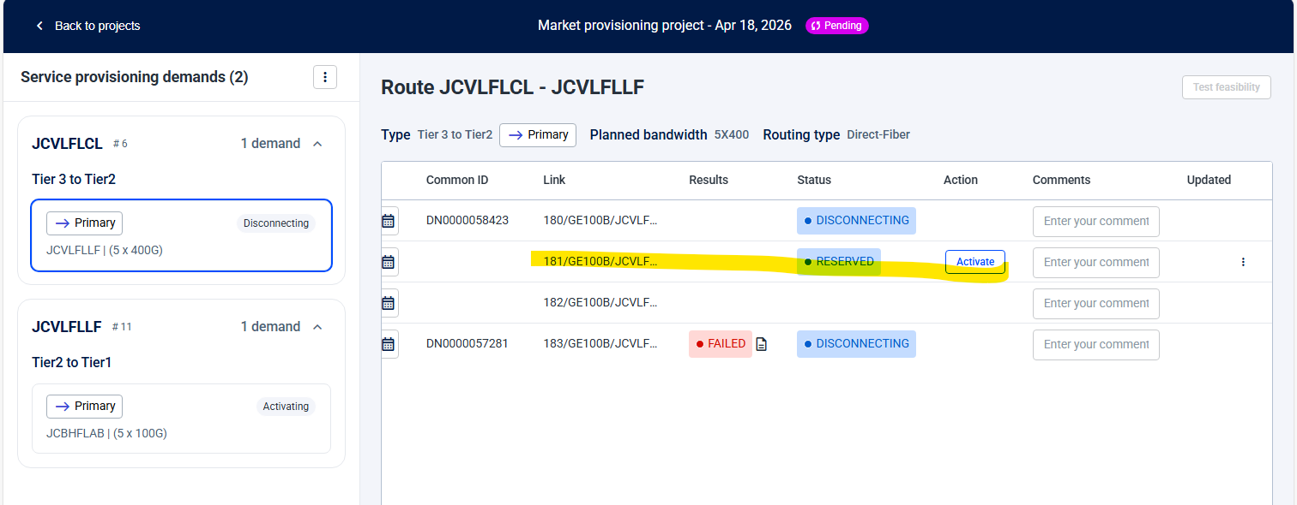
Validate db from below query
select cable_name,status_code,strand_index,reserved_for_clfi,is_deleted from inventory.cable_unit
where (cable_name='AR021001C' or cable_name='AR013001C') and strand_index=2
(change strand index one by one from above query and check)
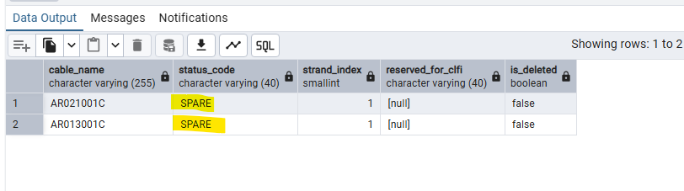
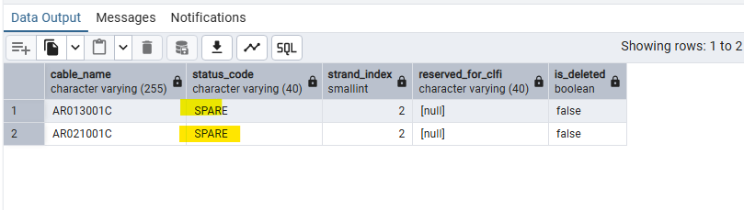
After cancel completed fiber_link_data is removed from inventory
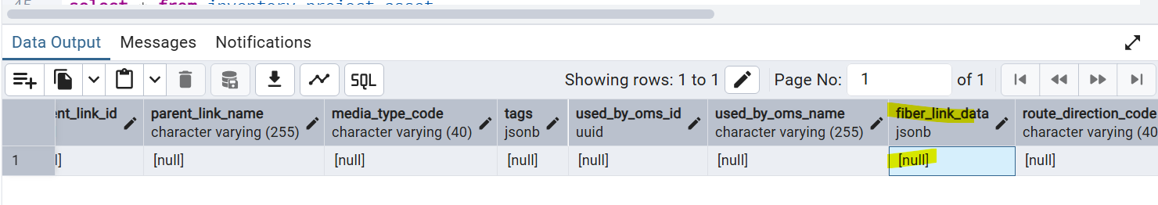

L1 EHB file used - Latest DOF l1 ANd EHB
Defects logged for DOF Create in SIT environment:
[DOF Cancel All Defects-SIT] Work item search - Introduction to Jira

Issue key | Summary | Status | Affects versions | Priority | Assignee | Components
AR-60093 | SIT| MOWFM | IO / DOF Cancel UC-4| MOWFM unable to display disconnect edge dispatch jobs on GUI. | Verified | v26.1 | High | Abhishek Kantamaneni | Planning Tool
AR-59915 | SIT |MOWFM| DOF Cancel| MOWFM unable to trigger disconnect edge jobs for DOF Cancel UC4. | Verified | v26.1 | Highest | Abhishek Kantamaneni | Planning Tool
AR-59890 | SIT| MOWFM | IO / DOF Cancel | Irrelevent event is triggered under TFDE server info | Open | v26.1 | Medium | Abhishek Kantamaneni | Planning Tool
AR-59403 | SIT| MOWFM |DOF Cancel UC-4 | As part of service delete, mowfm trying call to OWBC | Verified | v26.1 | Highest | Abhishek Kantamaneni | Planning Tool
AR-59131 | SIT| MOWFM | DOF Cancel | Received failure response from DAP on call back request for DAP-SERVICE-DELETE-CALL-BACK . Error : null for DOF cancel UC3 | Verified | v26.1 | Highest | Abhishek Kantamaneni | Planning Tool
AR-58725 | SIT| Planning_tool | IO/DOF Cancel| As part of Cancel, MOWFM unable to invoke Edge cancel | Verified | v26.1 | Highest | Abhishek Kantamaneni | Planning Tool

